
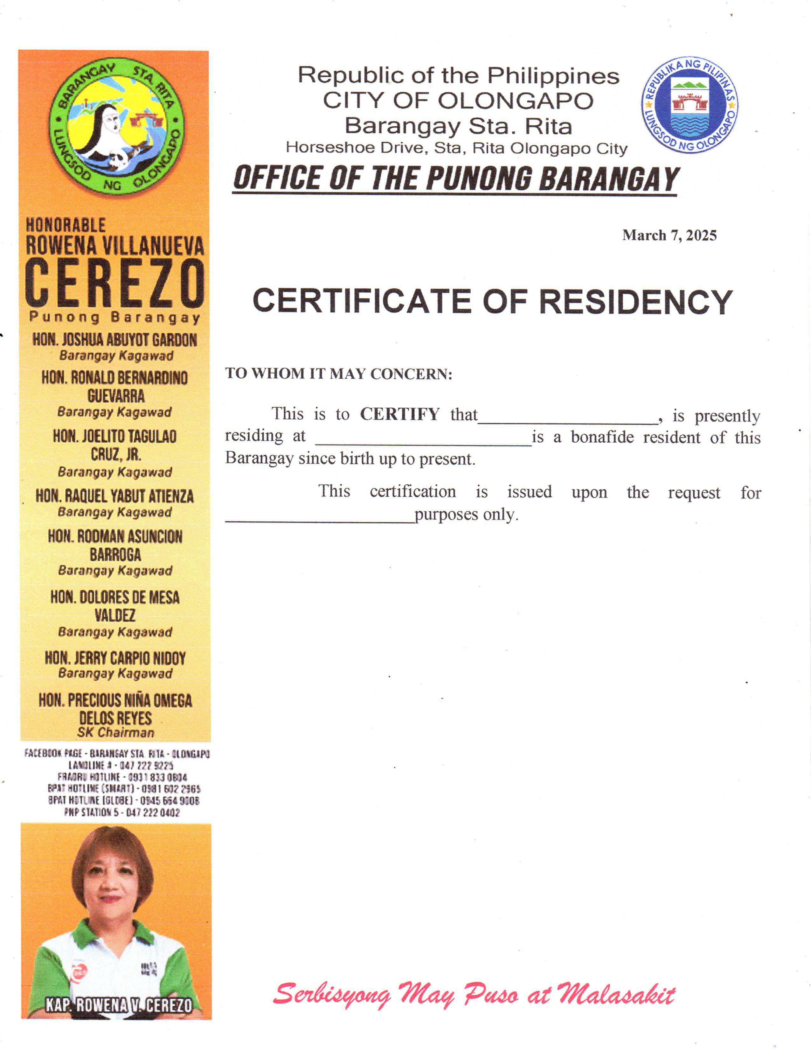
Republic of the Philippines CITY OF OLONGAPO Barangay Sta. Rita Horseshoe Drive, Sta. Rita Olongapo City OFFICE OF THE PUNONG BARANGAY
{dateRequested}

BARANGAY CLEARANCE
TO WHOM IT MAY CONCERN:
This to certify this person whose name, picture, Thumb mark and signature print appear here on, is a bonafide Resident of this barangay.

Date: {dateRequested}
Name: {fullName}
Address: {address}
Purok: {purok}
Birthday: {birthdate}
Purpose: {purpose}

NO DEROGATORY RECORD
______________
Signature
Res. Cert No.: {requestNumber}
Issued on: {issuanceDate}
Issued at: {placeOfIssuance}



